U.S. PRESIDENTIAL ELECTION

By Saju Jakob, LL.M, MBA, an Advocate at Supreme Court of India

If any election is fought as fiercely as US election that is only because of their spirit for deeply rooted values for democracy. “Somewhere inside all of us is the power to change the world." has rightly been said by Ronald Dahl and United States of America has exercised their right of adult suffrage to vote and decided the fate of their country. The long-haul process of US election has finally come to the Election Day on 3rd of November and the citizens have spoken out their will for Mr. Biden and Ms. Kamala. Now the whole world awaits the final declaration of presidential election from the court as Mr. Trump still claims the victory and has taken the election result for judicial review. A latest statement of Mr. Trump in the recent past have evoked a feeling of his surrender before the democratic forces and shows the sign of his readiness to accept the victory of Mr. Biden. We are just a few weeks away from January 20th when the President-elect would take his oath. Except China and Russia, and finally Trump, even Trump’s supporters, even famous Republicans like Mr. Collin Powell have accepted Biden’s victory for a change in US.
The Inception of US Presidential Elections
Held in 1788–1789 the US Presidential Elections was the first federal elections in the United States following the ratification of the United States Constitution in 1788. George Washington was elected as the first president of the United States .
Article Two of the Constitution of the United States established the method of presidential elections, including the creation of the Electoral College, which came as the result of a compromise between those constitutional framers who wanted Congress to choose the President, and those who preferred a national popular vote. The Electoral College refers to the group of presidential electors required by the constitution every four years, solely to elect president and vice president of the country. Currently the number of such electors is 538, out of which, consent of minimum 270 voters is required to choose a president or a vice president.

Originally under the system established by Article Two, electors used to cast votes for two different candidates for president. The candidate with the highest number of votes (provided it was a majority of the electoral votes) became the president, and the second-place candidate became the vice president but after the 12th amendment, which came after the elections of 1800, distinct votes were required for both president and vice president. If votes are not received from majority of the electors by any individual or if there is a ties, the House of Representatives would then select the president in a contingent election.In the 1788-1789, each state determined its own method of choosing Presidential electors, while many were appointed by state legislature, others were chosen through elections

Democrats vs. Republicans
Since ages, there are two major contemporary political parties contesting the US elections, namely, the Republican Party and the Democratic Party.
Democratic Party, founded on January 28, 1828by Thomas Jefferson and James Madison, is world's oldest active political partyand is currently chaired by Tom Penez. It evolved from the Jeffersonian Republican or Democratic-Republican Party organized by Jefferson and Madison in opposition to the Federalist Party in 1792. The Democratic Party supports for a mixed economy and believes in modern liberalism with notions of civil liberty and social equality. Corporate governance reform, environmental protection, support for organized labor, maintenance and expansion of social programs, affordable college tuition, universal health care, equal opportunity, and consumer protection form the core of the party's economic agenda.The Democrats have given 15 presidents so far, including John F. Kennedy, Franklin D. Roosevelt and Barack Obama.
On the other hand, the Republican party or the Grand Old Party, founded by the opponents of the Kansas-Nebraska Act in 1854 and is currently chaired Ronna McDaniel. The party supports classical liberalism, oppos the expansion of slavery, and supports economic reform. The party's 21st-century base of support includes people living in rural areas, men, the Silent Generation, and white evangelical Christians.American conservation, both economic and social values is the current ideology of the Republican Party. Lower taxes, free market capitalism, restrictions on immigration, increased military spending, gun rights, restrictions on abortion, deregulation and restrictions on labor unions are the few agendas of the Republican party.
Abraham Lincoln was the first Republican president. Under the leadership of Lincoln and a Republican Congress, slavery was banned in the United States in 1865. Current President Donald Trump is also a Republican.

The Candidates
The candidates for the US presidential elections for the post of president and vice president are Donald J. Trump and Mike Pence for the Republicans and Joseph R. Biden Jr. and Kamala Harris for the Democrats. Howie Hawkins and Angela Nicole Walker coming from Green Party and Jo Jorgensen along with Spike Cohen coming from Libertarian Party also stood for the elections including seven more candidates.

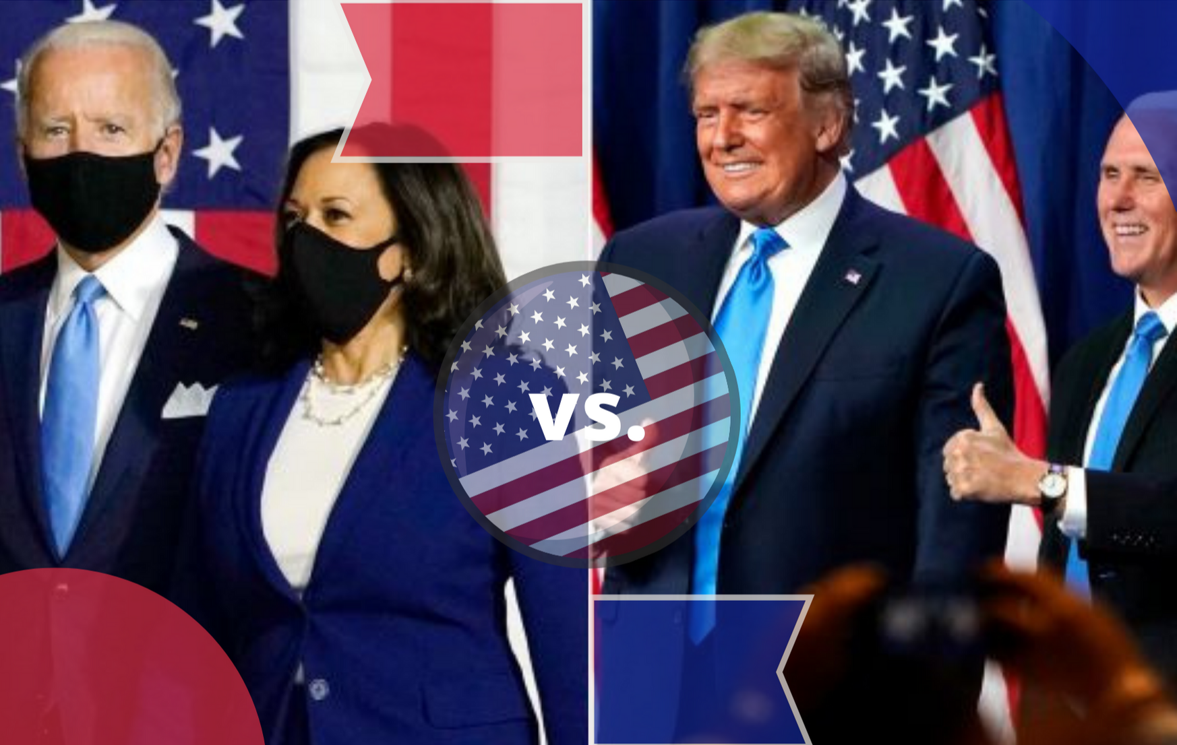

Joseph Biden has run for president twice before and is known for his down-to-earth personality and his ability to connect with working-class voters. He has been Vice President to Barack Obama for eight years and his key issue include restoring America’s standing on the global stage; adding a public option to the Affordable Care Act; strengthening economic protections for low-income workers in industries like manufacturing and fast food.

While Donald Trump's main legislative accomplishment as president is sweeping tax cut that chiefly benefited corporations and wealthy investors. Trump has focused on undoing the policies of the Obama administration, including those on health care, environmental regulations and immigration.
Trump's key issues include restricting immigration and building a wall at the Mexican border; renegotiating or canceling international deals on trade, arms control, and climate change; withdrawing American troops from overseas.
Eligibility
Article Two of the Constitution stipulates that for a person to serve as president,
(a) the individual must be a natural-born citizen of the United States,
(b) at least 35 years old, and
(c) a resident of the United States for a period of no less than 14 years.
A candidate may start running his or her campaign early before turning 35 years old or completing 14 years of residency but must meet the age and residency requirements by Inauguration Day. The Twenty-second Amendment to the Constitution also sets a term limit where a president cannot be elected to more than two terms.
Moreover, the Twelfth Amendment establishes that the vice-president must meet all the qualifications of being a president to be eligible for the elections.

Who can vote?
The eligibility of an individual for voting is set out in the Constitution of the United States and regulated at state level. The 15th, 19th and 26th Amendments to the Constitution state that suffrage cannot be denied on grounds of race or color, sex, or age for citizens eighteen years or older, respectively. And the specific requirements for voter eligibility and registration also vary by state, e.g. some states ban convicted felons from voting.
Nominations
The modern nominating process of U.S. presidential elections generally consists of two major parts. A series of presidential primary elections and caucuses are held in each state, and the presidential nominating conventions are held by each political party, although no provision regarding the same has been laid in the constitution.
The primary elections are run by state and local governments but the caucuses are organized by the political parties. Many states hold only primary elections while many holds only caucuses. In some states, combination of both is used. Presidential caucuses or primaries are indirect elections.Once selected, the nominees then start their political campaign so as to persuade voters.
US Presidential Election calendar
The 2020 United States presidential election is scheduled today i,e. November 3, 2020, every year. It will be the 59th presidential election. People vote for all the 538 presidential electors who in turn elect the president and the vice president on their behalf. Voters will select presidential electors who in turn will vote on December 14, 2020, to elect a new president and vice President. The series of presidential primary elections and caucuses were held from February to August 2020. On Wednesday January 6th, 2021, congress counts elector’s vote and certifies the electoral votes and declare the president and vice president. On January 20th, the President of United State of America officially becomes the President by taking oath from the Chief Justice of Supreme Court of America.

